Num1:

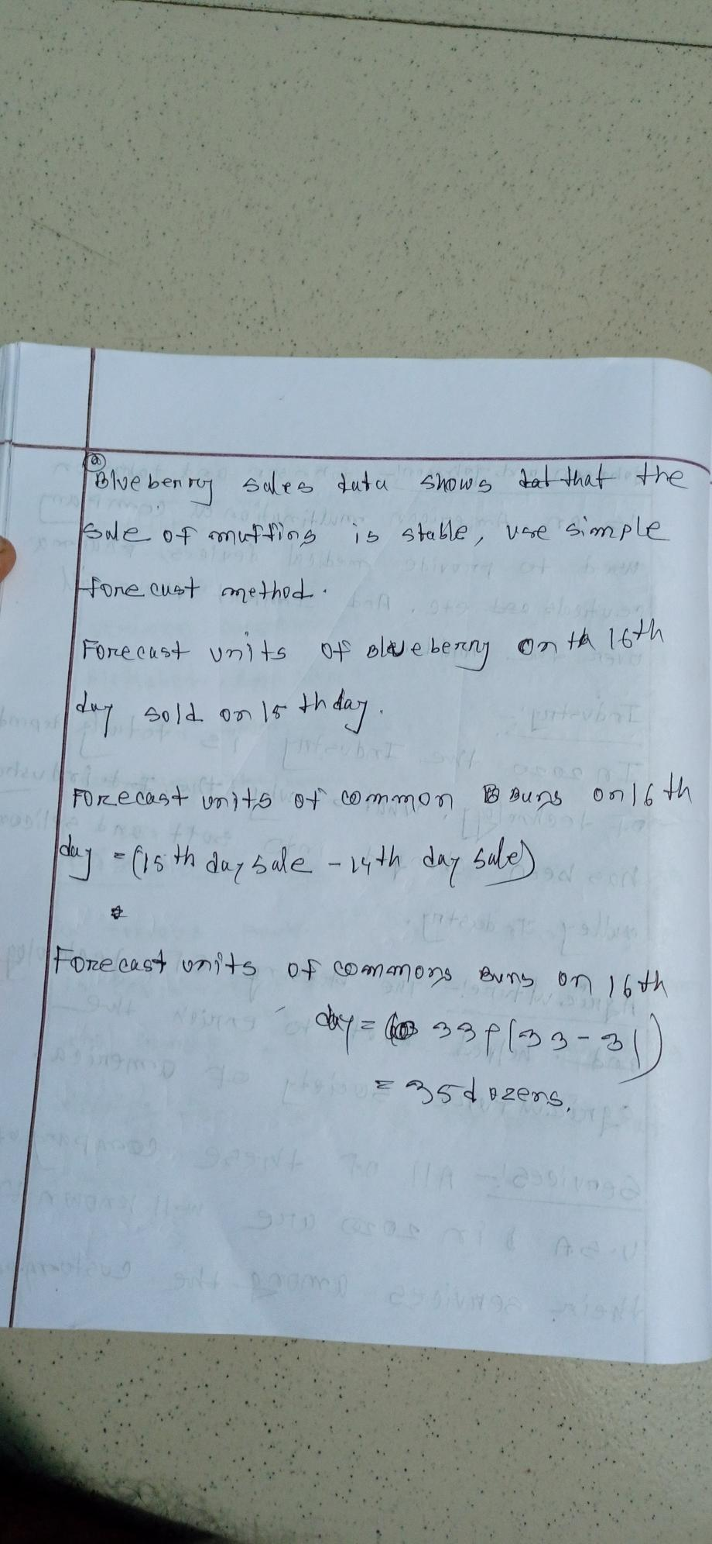

Math4:

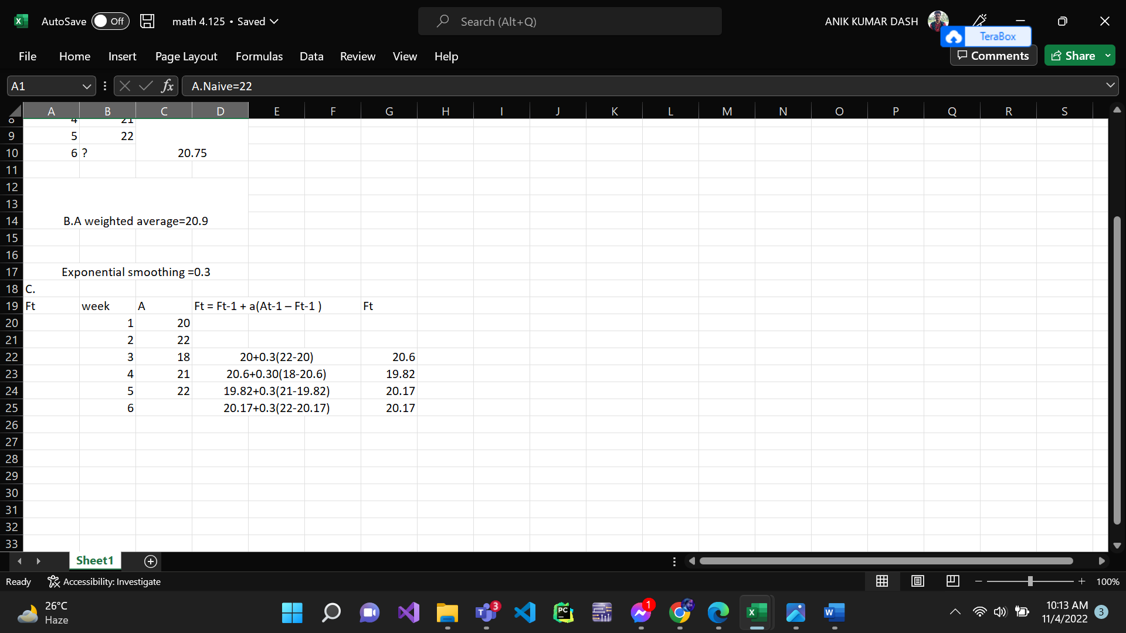

Slide 22:

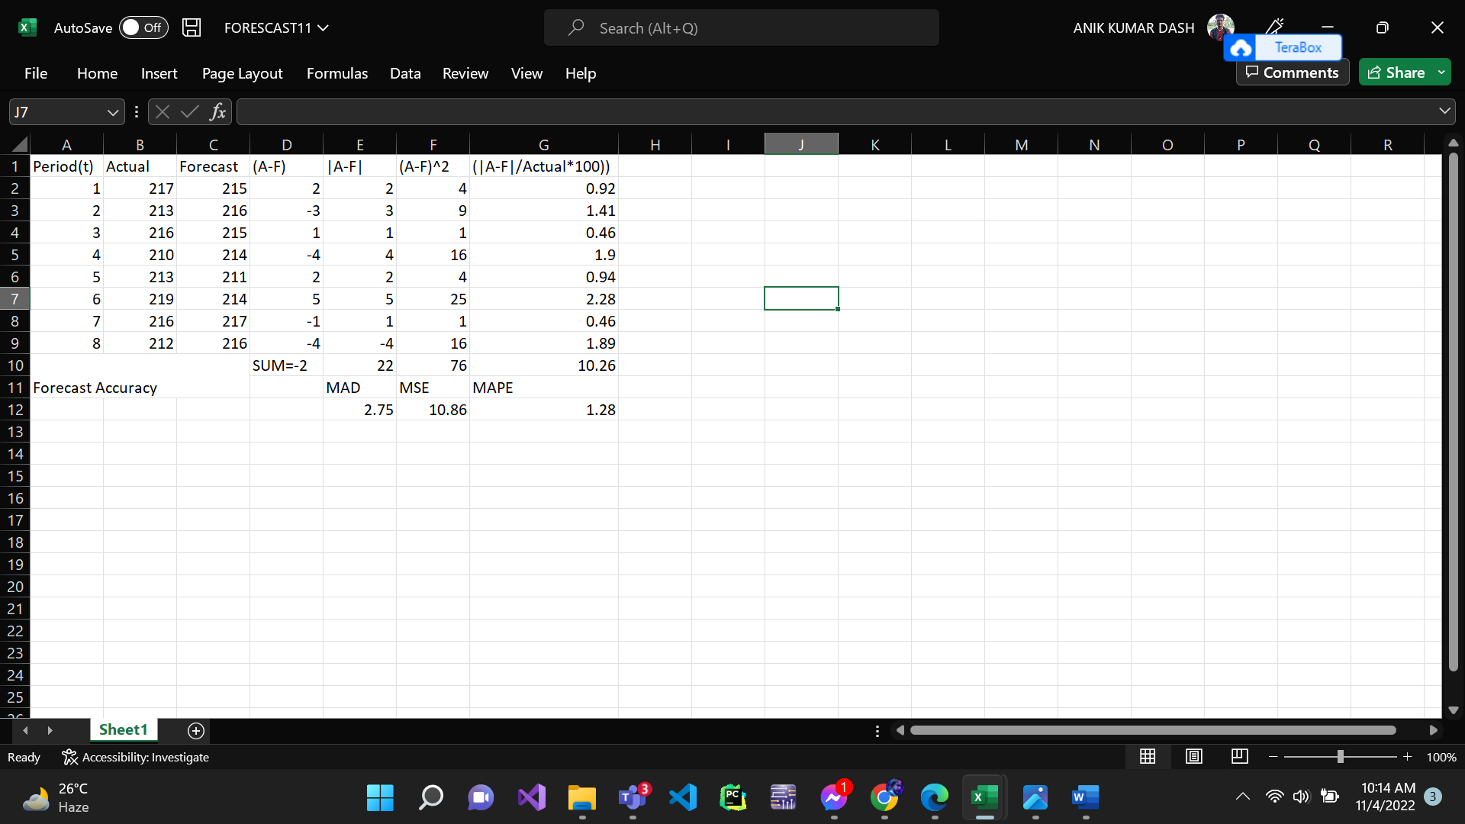

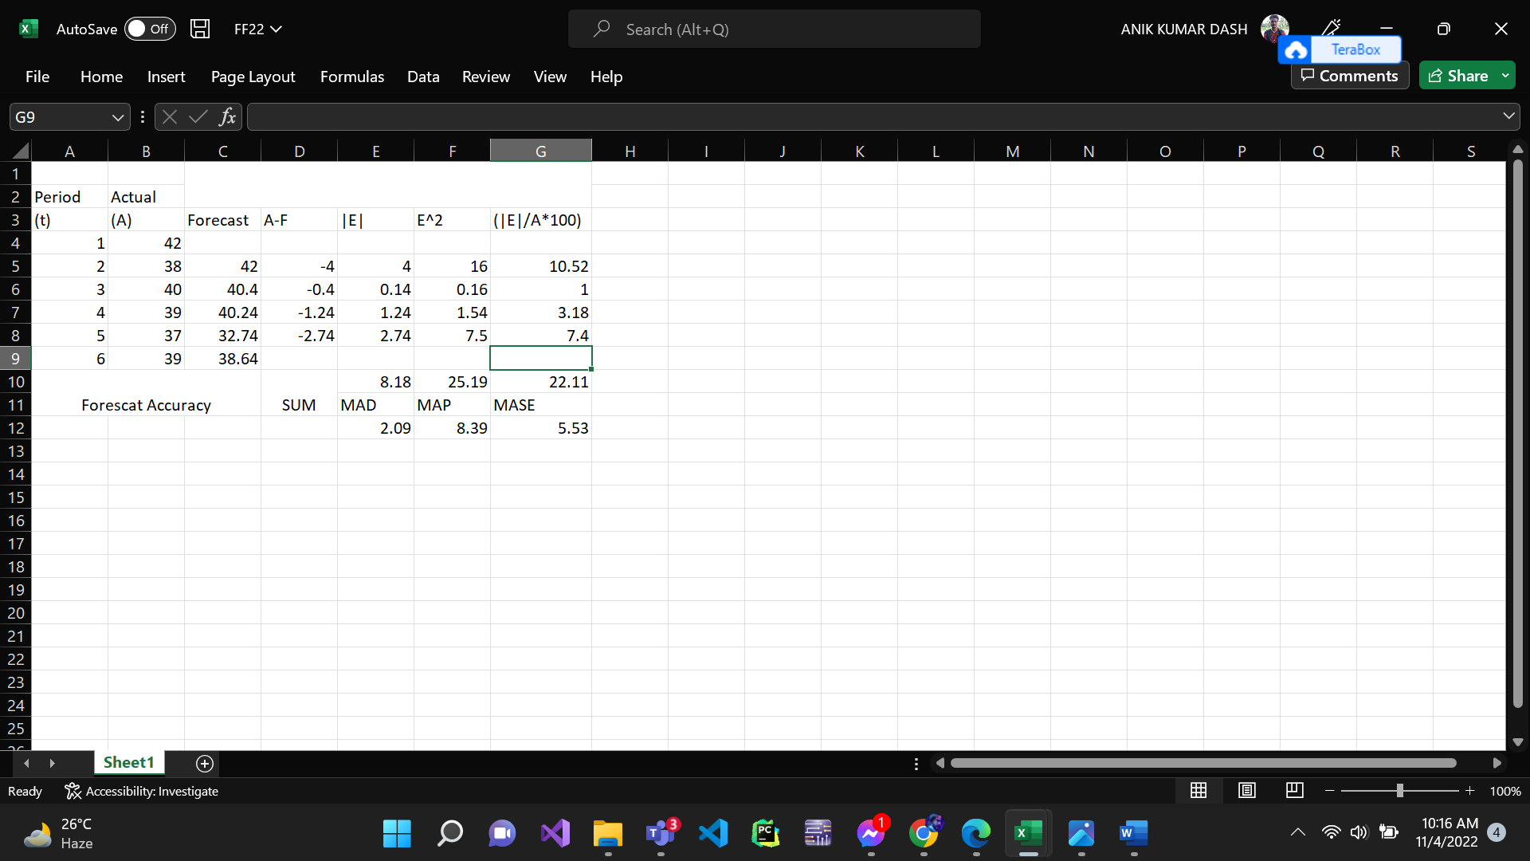

Pdf page 90:

